**CHAPTER 1: INTRODUCTION**

1.1 Introduction

In today’s digital era, the need for secure, reliable, and user-friendly identification methods has become increasingly important. Traditional approaches such as passwords, ID cards, and PINs often suffer from issues like theft, forgery, or being forgotten. Biometric authentication, especially face recognition, provides a more efficient solution as it uses unique human facial features that are difficult to duplicate.

This project aims to design and implement a Face Recognition System using a combination of Python, XML, HTML, and Live Server. The backend, powered by Python and OpenCV, handles face detection and recognition in real-time. XML is used for storing configuration details, dataset metadata, and recognition logs, ensuring structured data management. A web-based interface developed in HTML allows users to view the live video stream, recognition results, and system controls directly from their browser. By using Live Server, the project supports real-time testing and deployment, bridging the gap between local machine learning models and a lightweight, accessible front-end interface.

The system finds wide applications in areas such as attendance management, access control, surveillance, and smart automation, where quick and contactless identification is crucial. Its modular structure not only makes it easy to use but also allows scalability for future integration with advanced deep learning models.

**CHAPTER 2: DESCRIPTION**

The Face Recognition System is designed to provide a reliable, real-time, and user-friendly solution for authentication and security. It integrates Python for backend processing, XML for structured data storage, HTML for web-based interface, and Live Server for real-time deployment.

**2.1. Working Flow**

1. **Image Capture** – The system uses a webcam or camera to capture live video frames.
2. **Face Detection** – Faces are detected using Haar Cascades or Dlib HOG/CNN models.
3. **Feature Extraction** – Facial features are extracted using LBPH or deep learning embeddings.
4. **Database Matching** – Extracted features are compared with stored user data (saved in XML/database).
5. **Recognition Output** – If a match is found, the user’s identity is displayed in the HTML interface in real time.

**2.2. Backend (Python + OpenCV)**

* Handles face detection and recognition.
* Implements machine learning models for feature extraction.
* Stores recognition results and configurations in XML files.

**2.3. Frontend (HTML + Live Server)**

* Displays live camera feed and recognition results.
* Provides user-friendly controls for:
  + Adding new users
  + Updating datasets
  + Viewing recognition logs
* Runs on Live Server, enabling real-time browser interaction.

**2.4. Data Storage (XML)**

* Stores user IDs, names, recognition thresholds, and dataset metadata.
* Ensures structured, lightweight, and portable configuration management.

**2.5. Applications**

* **Attendance systems** in schools/colleges/offices.
* **Access control** in secure areas (labs, airports, offices).
* **Surveillance systems** for monitoring and tracking.
* **Smart automation** in IoT devices.

**2.6. Figures**

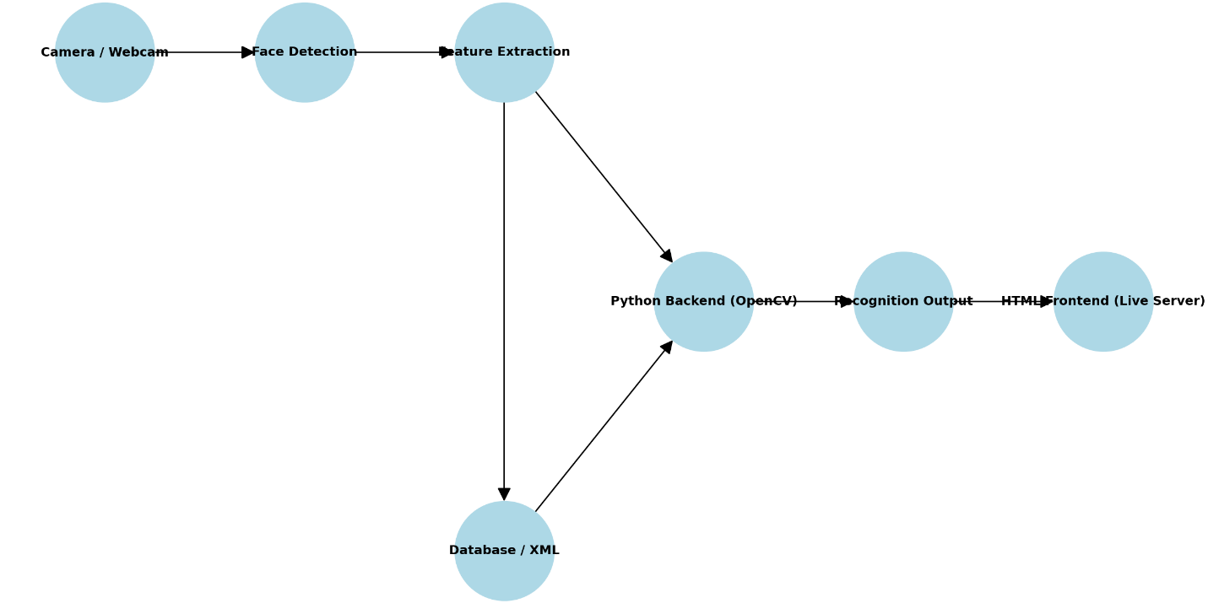

Fig 2.6.1: Flowchart

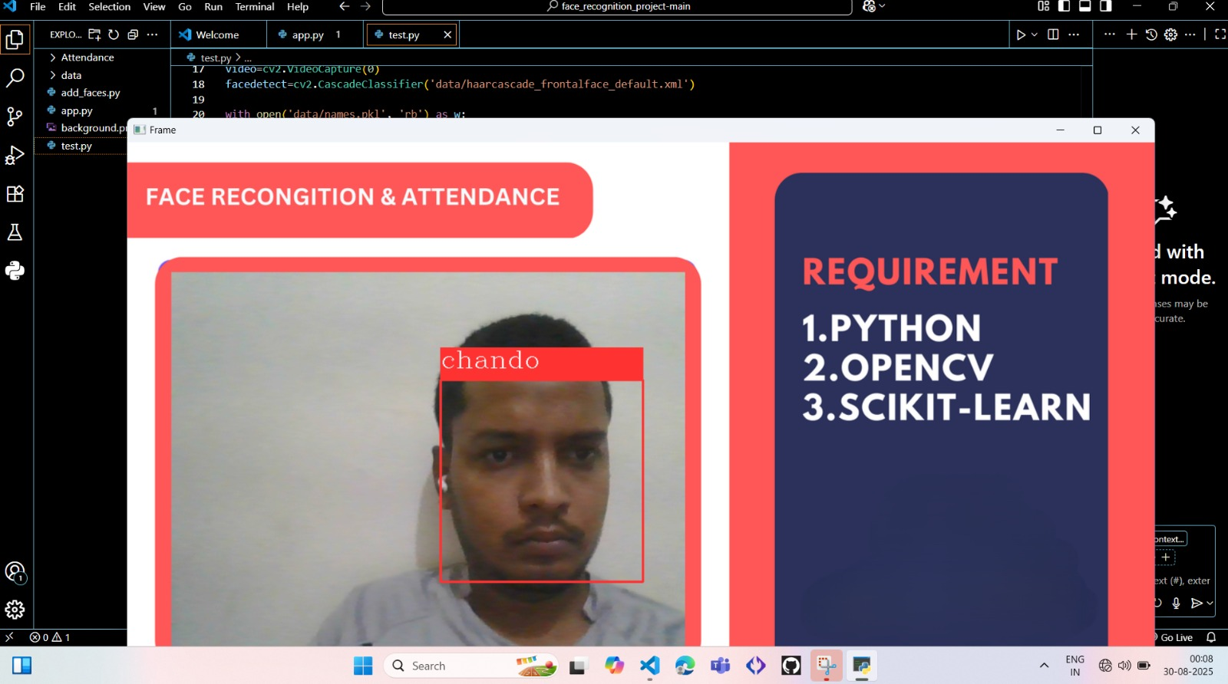

Fig 2.6.2: Interface

**CHAPTER 3: OBJECTIVES**

The main objectives of this project are:

1. **Develop a real-time face recognition system** capable of identifying individuals accurately using Python and OpenCV.
2. **Integrate a web-based interface** using HTML and Live Server to display live video feed and recognition results.
3. **Use XML for structured data storage**, including user information, recognition thresholds, and dataset metadata for easy management.
4. **Enable real-time interaction and control**, allowing users to add new faces, train the model, and view logs through the interface.
5. **Provide a secure, automated, and scalable solution** suitable for applications such as attendance management, access control, and surveillance.
6. **Ensure modularity and future scalability**, allowing the system to be upgraded with advanced deep learning models for improved accuracy.

**CHAPTER 4: LITERATURE REVIEW**

**Literature Review**

Face recognition technology has been extensively studied over the past few decades, with various algorithms and methods proposed to improve accuracy, speed, and robustness. The following key techniques and developments are relevant to this project:

1. **Haar Cascades (Viola-Jones Algorithm)**
   * One of the earliest and widely used approaches for real-time face detection.
   * Utilizes a cascade of simple classifiers applied to image features to detect faces efficiently.
   * Fast and effective for frontal face detection, but less robust for varied angles or occlusions.
2. **Eigenfaces and Fisherfaces**
   * Techniques based on Principal Component Analysis (PCA) and Linear Discriminant Analysis (LDA), respectively.
   * Eigenfaces reduce dimensionality by finding the principal components of facial images.
   * Fisherfaces improve discrimination between faces of different people by maximizing class separability.
   * Suitable for controlled environments but less effective under varying lighting or pose conditions.
3. **Local Binary Patterns Histogram (LBPH)**
   * A popular method for simple and fast face recognition.
   * Encodes the local texture of the face into histograms for comparison.
   * Performs well in real-time applications and with small datasets, which aligns with this project’s requirements.
4. **Deep Learning Approaches**
   * Modern face recognition relies on Convolutional Neural Networks (CNNs) and embedding techniques (e.g., FaceNet, OpenFace, Dlib).
   * Provides high accuracy even under variations in lighting, pose, or partial occlusion.
   * Requires larger datasets and more computational resources but offers state-of-the-art performance.
5. **Web-Based Interfaces for Face Recognition**
   * Integrating face recognition with web technologies allows interactive, real-time display of recognition results.
   * HTML frontends with Live Server provide a simple and flexible platform for deployment and user interaction.
   * XML and other structured data formats are commonly used for storing user information and system configurations in lightweight web-based applications.

**CHAPTER 5: CHALLENGES FACED**

During the development, implementation, and testing of the Face Recognition System, several challenges were encountered. Addressing these challenges was critical to ensure the system performed accurately and efficiently in real-time applications:

1. **Lighting Variations**
   * One of the primary challenges in face recognition is handling different lighting conditions. Faces captured in low light or harsh shadows can reduce detection accuracy.
   * Variations in illumination across the environment caused difficulties in feature extraction, as the system relies on consistent image quality for precise recognition.
   * To mitigate this, preprocessing techniques like histogram equalization were implemented, but performance could still degrade under extreme conditions.
2. **Pose and Angle Variations**
   * The system performs optimally when faces are frontal and aligned. However, in real-world scenarios, faces may be tilted, rotated, or partially turned away from the camera.
   * Such pose variations caused the model to misidentify or fail to recognize certain individuals. Handling these variations requires more advanced algorithms like deep learning models trained on multi-angle datasets.
3. **Occlusion and Accessories**
   * Faces may be partially blocked by masks, glasses, scarves, hats, or hair, which obstructs key facial features.
   * This significantly affects recognition accuracy since traditional algorithms like LBPH rely on visible local patterns.
   * Although deep learning approaches can handle some occlusion, implementing them requires larger datasets and higher computational resources.
4. **Real-Time Performance**
   * Achieving fast processing of live video while maintaining high recognition accuracy was a challenge.
   * The system must detect faces, extract features, and compare them against a dataset for every frame.
   * On machines without GPU acceleration, balancing speed and accuracy was difficult. Optimizations in code and preprocessing were necessary to reduce latency and ensure a smooth user experience.
5. **Data Management and XML Handling**
   * Storing user information, recognition thresholds, and dataset metadata in XML required careful structuring to avoid errors.
   * As the number of users increased, managing XML files efficiently became challenging. Ensuring proper synchronization between Python backend processes and XML data was critical to maintain data consistency.
   * Future scalability would require either database integration or optimized XML parsing strategies to handle larger datasets effectively.
6. **Integration of Frontend and Backend**
   * Connecting the Python backend with the HTML interface via Live Server posed challenges in real-time communication.
   * Ensuring that the recognition results were updated dynamically on the web interface, while the video feed continued smoothly, required careful handling of asynchronous processes and data exchange formats like JSON.
7. **Environmental and Hardware Constraints**
   * The performance of the system also depended on hardware limitations such as camera quality, processing speed, and memory.
   * Lower resolution cameras reduced detection precision, and limited hardware could not handle complex computations required by deep learning models in real-time.

**CHAPTER 6: FUTURE SCOPE**

The Face Recognition System developed in this project provides a solid foundation for real-time identification and security applications. However, there are several areas where the system can be extended, enhanced, and adapted to meet broader requirements and leverage emerging technologies:

1. **Integration with Advanced Deep Learning Models**
   * While the current system uses LBPH or basic recognition methods, implementing deep learning-based models such as FaceNet, ArcFace, or Dlib’s CNN embeddings can significantly improve accuracy, especially under varied lighting, occlusion, or pose conditions.
   * These models can also support large-scale datasets, making the system suitable for enterprise-level deployment.
2. **Cloud-Based Deployment**
   * Moving the system to a cloud-based infrastructure can enable centralized data storage, remote access, and real-time recognition across multiple locations.
   * Cloud deployment also allows leveraging GPU acceleration and higher computational resources for faster processing and improved model performance.
3. **Mobile and IoT Integration**
   * The system can be adapted for mobile devices or IoT-based smart devices, such as smart doors, security cameras, or automated attendance terminals.
   * This would allow contactless authentication in offices, educational institutions, and public facilities.
4. **Enhanced Security Features**
   * Incorporating anti-spoofing techniques, such as detecting photographs, masks, or videos, will improve the system’s security and robustness.
   * Multi-factor authentication combining face recognition with other biometric or token-based methods can be integrated for high-security environments.
5. **Support for Masked or Partially Occluded Faces**
   * The system can be enhanced to recognize faces even when partially covered by masks, glasses, or scarves—a requirement made more relevant due to current global health concerns.
   * Specialized models trained on occluded face datasets can address this challenge.
6. **Automated Attendance and Analytics**
   * Beyond recognition, the system can be extended to automatically mark attendance, generate reports, and analyze patterns such as time spent in premises or frequency of entry/exit.
   * Integration with data visualization dashboards can provide management insights and improve operational efficiency.
7. **Scalability for Large Databases**
   * The current XML-based data storage is suitable for small to medium datasets.
   * Future enhancements could involve relational databases (MySQL, PostgreSQL) or NoSQL databases (MongoDB) to efficiently handle thousands of users and maintain high retrieval speed.
8. **Cross-Platform and Multi-Language Support**
   * The HTML front end can be extended to support responsive web design, making it accessible on desktops, tablets, and smartphones.
   * Multi-language support can make the system more versatile and user-friendly in diverse environments.

**CHAPTER 7: CONCLUSIONS**

The development of the Face Recognition System demonstrates the practical application of computer vision, machine learning, and web technologies for real-time identity verification. This project successfully integrates Python for face detection and recognition, XML for structured data management, and HTML with Live Server for a responsive, interactive web interface.

Key conclusions from the project include:

1. **Effectiveness of Face Recognition**
   * The system can accurately detect and recognize individuals in real-time under controlled conditions.
   * LBPH and basic machine learning techniques provide sufficient accuracy for small to medium-sized datasets, while the modular design allows future integration of deep learning models for higher performance.
2. **Real-Time Performance and Interaction**
   * The HTML interface enables real-time monitoring of the camera feed and recognition results, demonstrating effective communication between the backend and frontend.
   * Live Server facilitates rapid testing and interaction, making the system suitable for deployment in educational, office, or security environments.
3. **Data Management and Scalability**
   * XML-based storage provides a lightweight and organized way to manage user information, model parameters, and recognition logs.
   * The design ensures easy expansion and adaptation to larger datasets or more complex storage solutions such as databases in the future.
4. **Challenges and Learning**
   * The project highlights challenges such as variations in lighting, pose, occlusion, and real-time performance optimization.
   * Addressing these challenges provides insights into preprocessing, data handling, and system optimization necessary for real-world deployment.
5. **Applications and Future Potential**
   * The system is suitable for applications in attendance management, access control, surveillance, and smart automation.
   * With enhancements such as deep learning integration, cloud deployment, and mobile/IoT adaptation, the system has strong potential for wider adoption in security and automation solutions.

**REFERENCES**

1. Viola, P., & Jones, M. (2001). *Rapid Object Detection Using a Boosted Cascade of Simple Features*. Proceedings of the 2001 IEEE Computer Society Conference on Computer Vision and Pattern Recognition.
2. Turk, M., & Pentland, A. (1991). *Eigenfaces for Recognition*. Journal of Cognitive Neuroscience, 3(1), 71–86.
3. Ahonen, T., Hadid, A., & Pietikäinen, M. (2006). *Face Description with Local Binary Patterns: Application to Face Recognition*. IEEE Transactions on Pattern Analysis and Machine Intelligence, 28(12), 2037–2041.
4. Schroff, F., Kalenichenko, D., & Philbin, J. (2015). *FaceNet: A Unified Embedding for Face Recognition and Clustering*. Proceedings of the IEEE Conference on Computer Vision and Pattern Recognition (CVPR), 815–823.
5. OpenCV Documentation. https://docs.opencv.org
6. Dlib Library Documentation. http://dlib.net
7. W3Schools HTML Guide. https://www.w3schools.com/html/
8. W3Schools XML Guide. https://www.w3schools.com/xml/
9. Stack Overflow Community. *Python OpenCV Face Recognition Discussions*. [https://stackoverflow.com/](https://stackoverflow.com/?utm_source=chatgpt.com)
10. GitHub Repository Examples: Face Recognition Python Projects. [https://github.com/topics/face-recognition](https://github.com/topics/face-recognition?utm_source=chatgpt.com)